AKHILA SINGARAJU

DATA WAREHOUSING

**INTRODUCTION**

This assignment is focused on analyzing patterns of adolescent alcohol use in Oklahoma, specifically targeting respondents aged 18-24. The primary objective is to identify which areas in the state have the highest and lowest percentages of alcohol abuse among adolescents and to draw meaningful insights from the dataset.

### Goals and Expectations

The main goal of this assignment is to calculate the percentage of adolescent respondents who reported alcohol abuse, broken down by city and county. This analysis aims to uncover trends in alcohol consumption, helping us understand how widespread alcohol abuse is in different parts of Oklahoma.

### Selected Dataset

The dataset used for this analysis comes from the Behavioral Risk Factor Surveillance System (BRFSS) for Oklahoma. It focuses specifically on alcohol use among the 18-24 age group, capturing key variables such as geographic information (city, county, zip code), demographic breakouts (age, gender, and income), and quantitative data on alcohol use (sample size and the number of respondents who identified as heavy drinkers). This dataset provides a solid foundation for examining trends in alcohol consumption across different regions.

### Tools and Languages

For this assignment, I will primarily use **MySQL** to manage and analyze the data. The data will be organized into a **star schema** to streamline the querying process, allowing for efficient data analysis**. MySQL Workbench** will serve as the main interface for creating the database, running SQL queries, and performing calculations on the dataset. SQL will be the primary language used for querying, aggregating, and analyzing the data to generate insights into adolescent alcohol abuse patterns across Oklahoma.

With the combination of SQL for analysis and the BRFSS dataset, this assignment will provide insights into how alcohol consumption affects adolescents in Oklahoma, helping to identify the regions with the highest and lowest levels of alcohol abuse.

**RESEARCH**

**EXPLORING BRFSS DATA:**

The BRFSS dataset provided includes information about heavy drinking among adults in Oklahoma in 2009, broken down by different demographic groups and geographic locations. The dataset contains the following key columns, which are useful for analyzing the prevalence of heavy drinking:

**Columns Overview:**

* **Question**: This column contains the specific question asked in the survey. In this dataset, the question is focused on identifying heavy drinkers. Specifically, it tracks adult men who consume more than two drinks per day and adult women who consume more than one drink per day.
* **Response**: This column records the response to the question. In the current dataset, all responses are recorded as "Yes," meaning that the respondents confirmed they are heavy drinkers according to the defined criteria. There are no "No" responses in this dataset, which indicates it only captures those who answered affirmatively.
* **Break_Out**: This column shows the subgroups or categories in which respondents are classified. For example, it might represent income levels, age groups, or other demographics. In this assignment, we will focus primarily on Age groups 18-24.
* **Break_Out_Category**: This column provides context for the "Break_Out" values. In this dataset, one of the categories is "Household Income," which means the breakout groups are categorized by income levels. This column also includes other demographic groupings in different datasets (e.g., education level, gender, or age).
* **Sample_Size**: This column contains the number of people in each demographic group who were asked the question. It indicates the total number of respondents in a particular breakout group (e.g., the total number of people within the $15,000-$24,999 income range who were surveyed). This provides insight into how representative the data is for each group.
* **Data_value**: This column gives the number of respondents who answered "Yes" to the question about heavy drinking. It represents the number of heavy drinkers within each breakout group. For example, if the data value is 57 for a certain ZIP code and income group, it means that 57 people in that group identified themselves as heavy drinkers.
* **Zip Code**: This column represents the geographic location of the respondents, broken down by ZIP code in Oklahoma. It allows for geographic analysis, showing how heavy drinking patterns vary across different areas. By analyzing ZIP codes, we can potentially identify regions with higher concentrations of heavy drinkers.

**EXPLORING ‘YES’ RESPONSES RELEVANT TO ADOLSECENTS:**

The dataset contains survey responses related to the **18-24 age group**, which is relevant for analyzing adolescent alcohol consumption, especially for young adults. Here are some key insights from the data:

* **Break_Out**: This column shows the age group “18-24,” representing younger adults who are within the adolescent to college-age range.
* **Break_Out_Category**: The category for this breakout is “Age Group.”
* **Sample_Size**: The number of respondents in the 18-24 age group varies across different ZIP codes. For example, one ZIP code had 105 respondents, while another had 169.
* **Data_value**: The number of respondents in the 18-24 age group who answered “Yes” to heavy drinking varies across ZIP codes. In some ZIP codes, up to 158 respondents were classified as heavy drinkers.

In this query, I am attempting to identify groups of adolescents (aged 18-24) with alcohol abuse response in Oklahoma City.

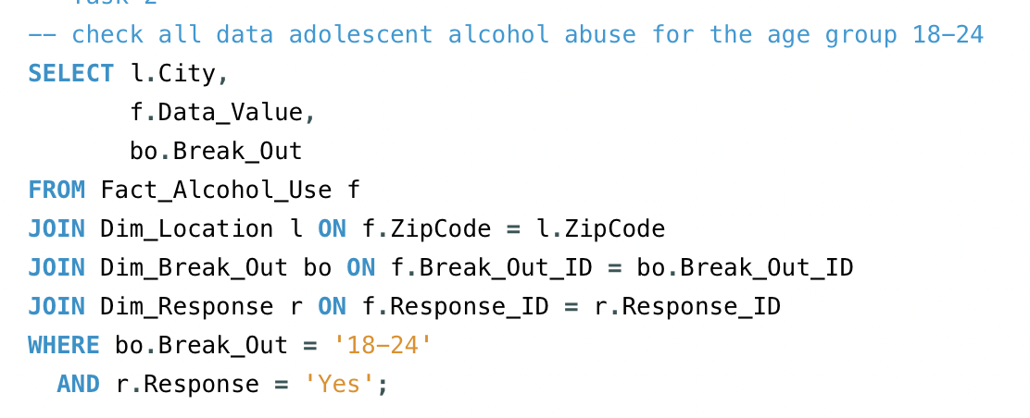

* I have identified multiple data points for individuals aged 18-24, with varying alcohol use values (ranging from 4 to 163).
* This gives us an overview of the adolescents, who answered yes to the heavy drinking.

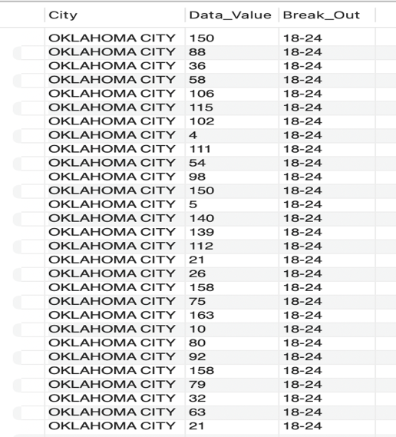

**METHODS TO IDENTIFY GROUPS OF ADOLSECENTS WITH HIGHEST RISK FOR ALCOHOL ABUSE:**

1. Finding the zip code with highest average adolescent alcohol consumption.

In this query, I am trying to identify the zip code with the highest average adolescent alcohol consumption based on the data available. Specifically, I want to know which zip code has the highest reported rates of alcohol use among adolescents aged 18-24, so we can find out the adolescent groups who are at highest risk.

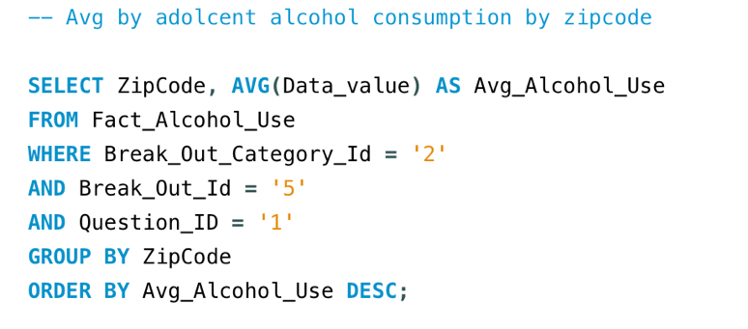

Interpretation:

* The zip code **73140** has the highest average adolescent alcohol consumption, with an average of **163** respondents identifying as heavy drinkers.
* Other zip codes like **73144** and **73124** also show high average alcohol consumption, both at **158**.
* The results provide a clear picture of the geographic distribution of adolescent alcohol use, allowing us to focus on the zip codes where the problem appears most severe.

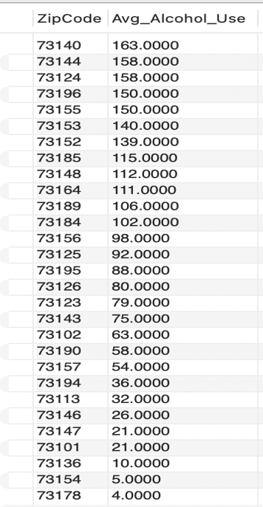

**CREATING ERD:**

**Creating Fact Table:**

**Step 1:**  
I began the process of creating my ERD by selecting the "Star Schema" option in the ERDPlus tool. I named the diagram "OKLAHOMA" to reflect the focus of the analysis on the OKLAHOMA state. This step laid the groundwork for organizing the necessary tables and defining the relationships between them.

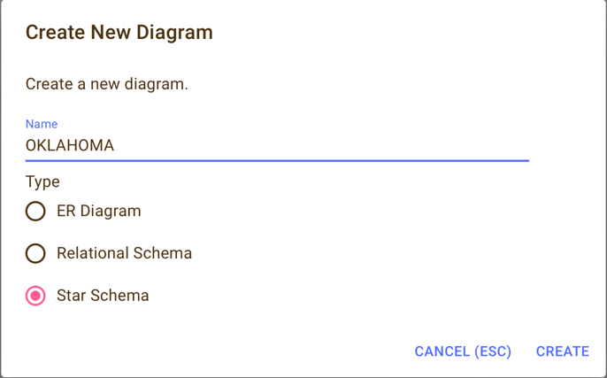

**Step 2:**

For the second step, I selected the "Fact" option in the ERDPlus tool. This allowed me to define the fact table that will hold the quantitative data needed for my analysis. By choosing the "Fact" option, I created **the FACT_ALCOHOL_USE** table.

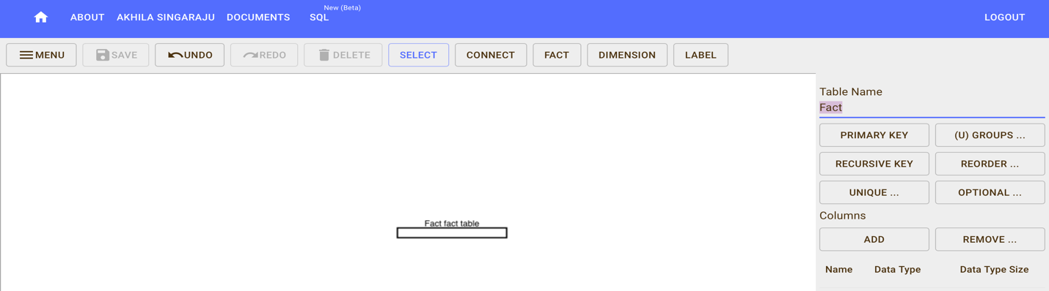

**Step 3:**

In the next step, I renamed the fact table to FACT_ALCOHOL_USE to align with the dataset's focus. Then, I proceeded to add columns by selecting the "Add" option, creating fields such as Fact_ID, Sample_size, and Data_value to capture the key quantitative details relevant to the analysis.

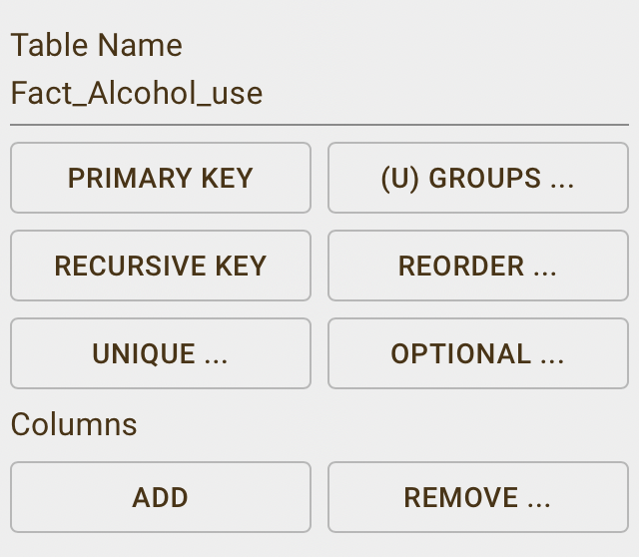 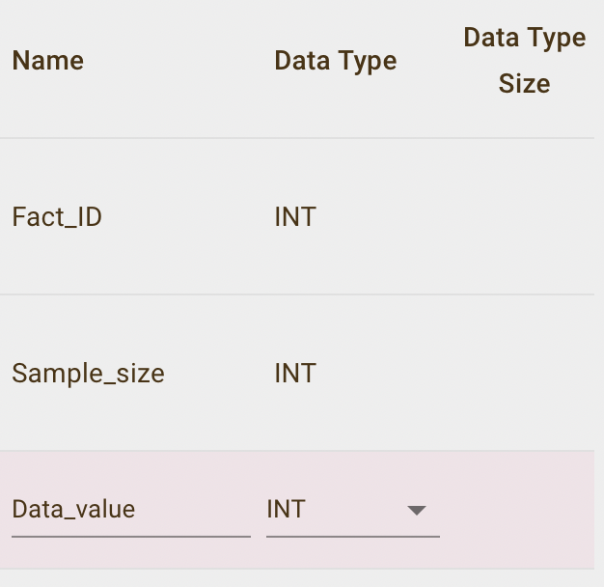

**Step 5:**

I selected Fact_Id in this as Primary key.

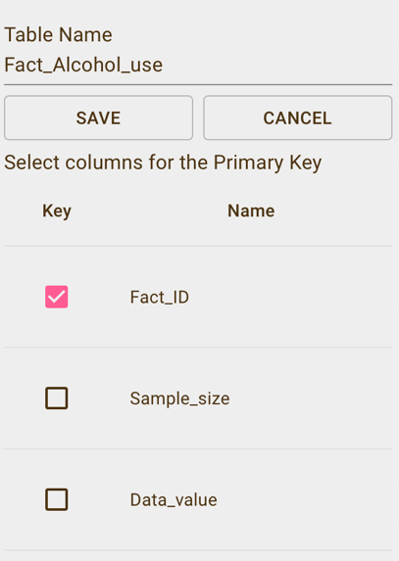

**Step 5:**

I created the **Fact_Alcohol_Use** fact table, which includes three key columns: **Fact_ID, Sample_size**, and**Data_value**. These columns are designed to store essential quantitative data, such as the unique identifier for each record, the sample size for each observation, and the reported alcohol use values for analysis.

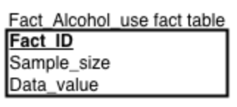

**Creating Dim_Break_out table:**

**Step 1:**

After setting up the fact table, I proceeded to create the dimension table named **Dim_Break_Out**. I clicked on the "Dimension" option within the ERDPlus tool, which allowed me to define the dimension table that will store the demographic data relevant to my analysis. By selecting the "Dimension" option, I was able to create the **Dim_Break_Out** table.

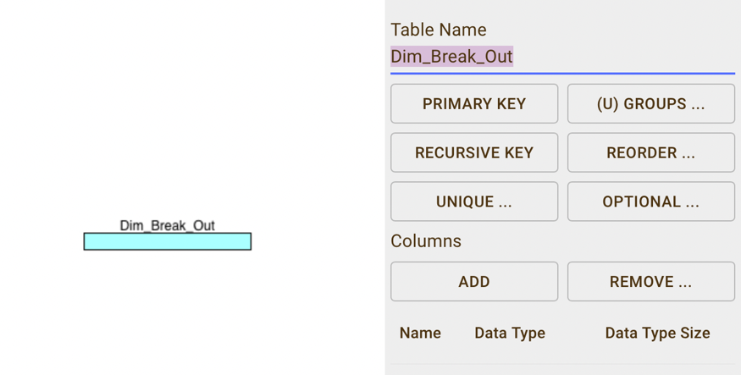

**Step 2:**I proceeded to add columns to the **Dim_Break_Out** table by selecting the "Add" option. I created fields such as **Break_Out_ID** (as an integer) and **Break_Out** (as a VARCHAR) to store the unique identifier and the description of the breakout categories, such as age groups or demographic distinctions.

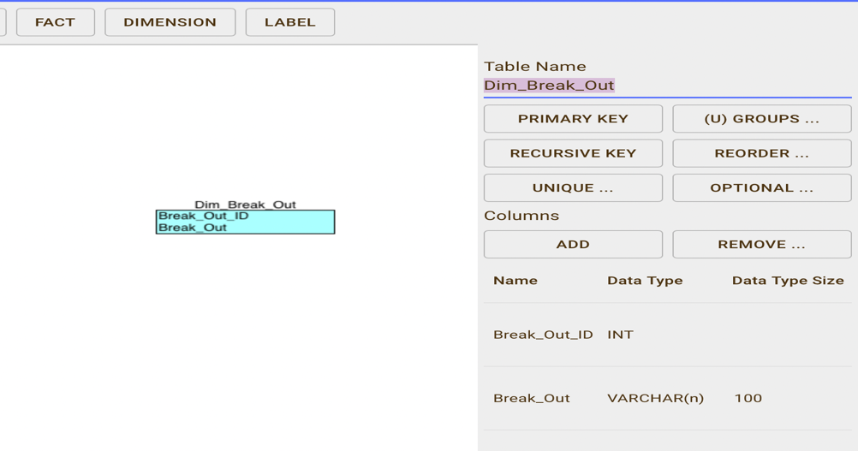

**Step 3:**I selected the **Primary Key** option for the **Dim_Break_Out** table to ensure that each record could be uniquely identified. I chose **Break_Out_ID** as the primary key to serve as the unique identifier for each breakout category in the dataset.

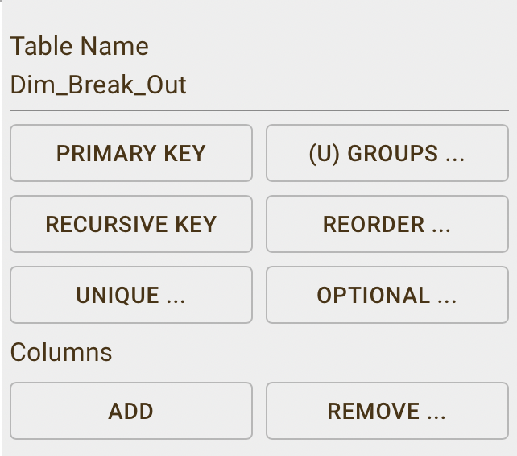 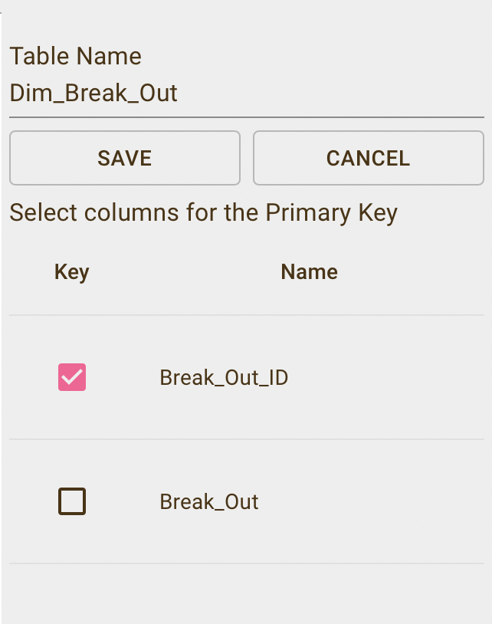

**Step 4:**I finalized the structure of the **Dim_Break_Out** table, which includes two key columns: **Break_Out_ID** and **Break_Out**. The **Break_Out_ID** serves as the primary key, while **Break_Out** holds the descriptive information for each breakout group, such as age categories or other demographic classifications.

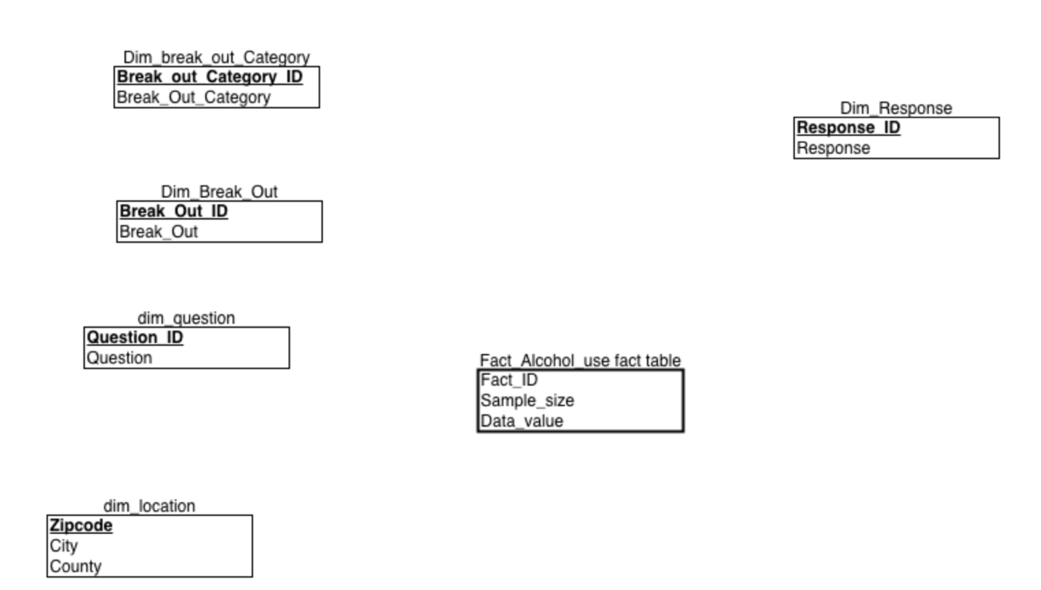

**Creating Dim_Break_out _Category table:**

**Step 1:**Next, I created the **Dim_break_out_Category** table to store categorical data that relates to the breakout groups in the analysis.

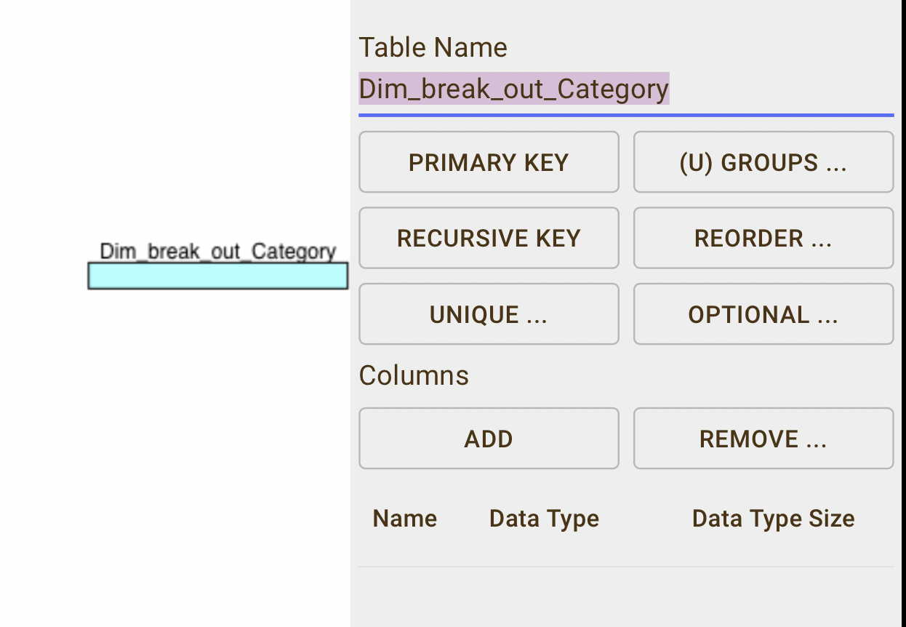

**Step 2:**

I added columns to the **Dim_break_out_Category** table by selecting the "Add" option. I included fields such as **Break_out_Category_ID** (as an integer) and **Break_Out_Category** (as a VARCHAR) to store the unique identifier and descriptive name for each category.

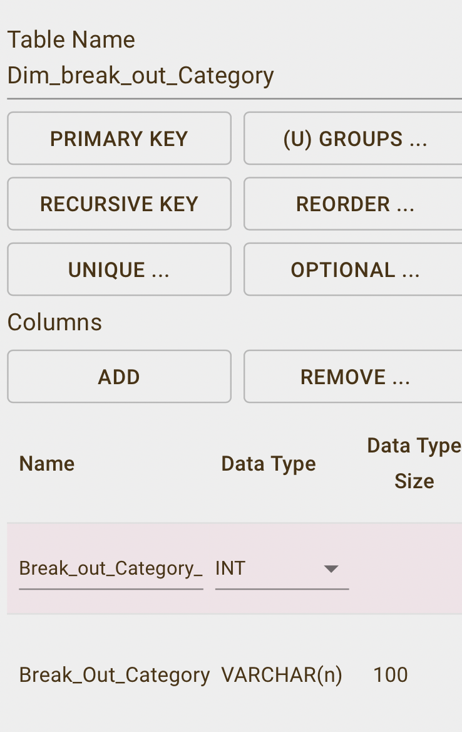

**Step 3:**

I selected the **Primary Key** option for the **Dim_break_out_Category** table to uniquely identify each record. I chose **Break_out_Category_ID** as the primary key to ensure that each breakout category is distinctly represented in the table.

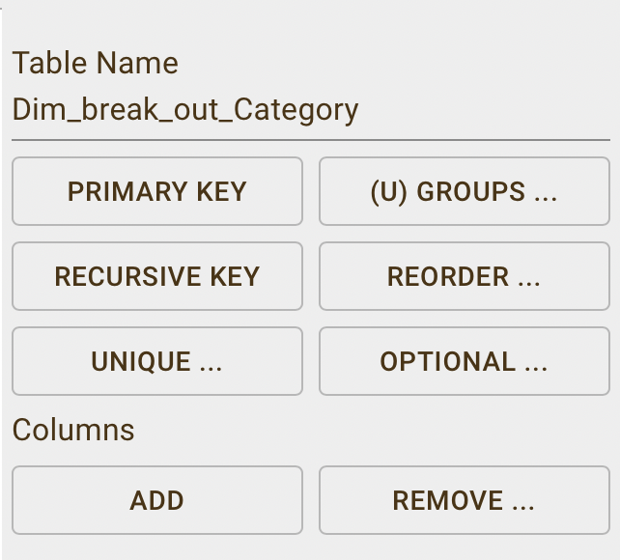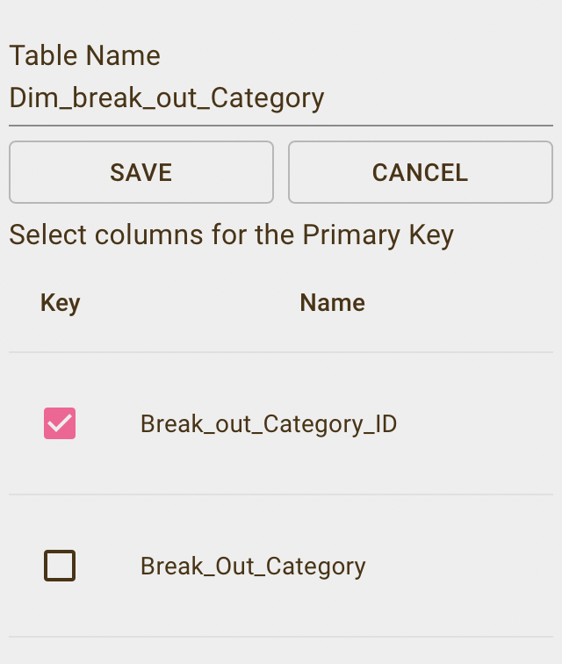

**Step 4:**

I finalized the **Dim_break_out_Category** table by including two key columns: **Break_out_Category_ID** and **Break_Out_Category**. The **Break_out_Category_ID** serves as the primary key, uniquely identifying each breakout category, while **Break_Out_Category** holds the descriptive information for each category.

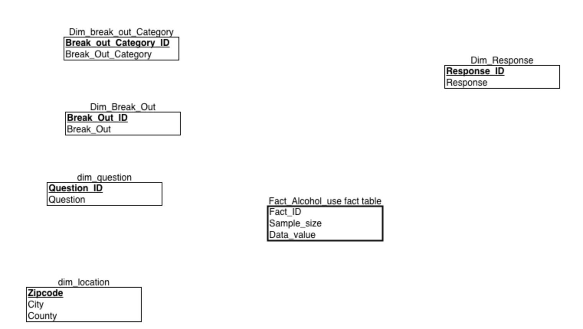

**Creating Dim_question table:**

**Step 1:**

After creating break_out_Category table, I created the **Dim_ question** table to store categorical data that relates to the question in the analysis.

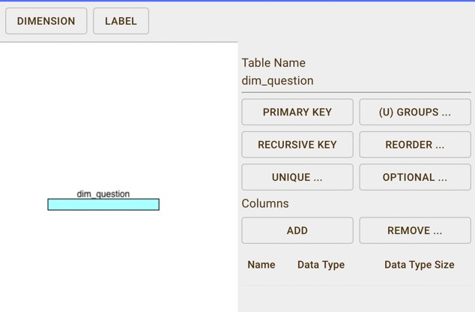

**Step 2:**

I added columns to the **Dim_** questiontable by selecting the "Add" option. I included fields such as **Question**_ID(as an integer) and **Question** (as a VARCHAR) to store the unique identifier and Question.

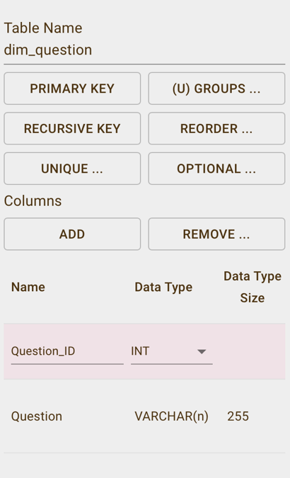

**Step 3:**

I selected the **Primary Key** option for the **Dim_Question** table to uniquely identify each record. I chose **Question _ID** as the primary key to ensure that each breakout category is distinctly represented in the table.

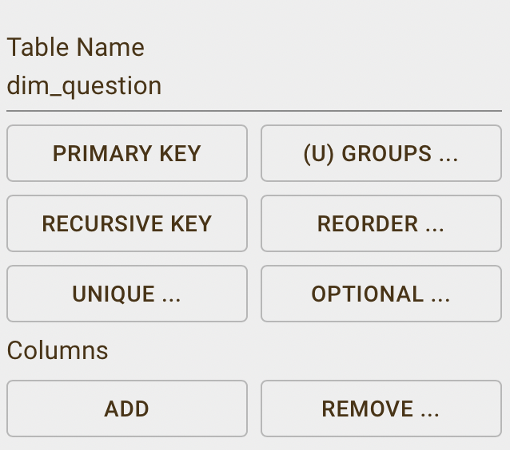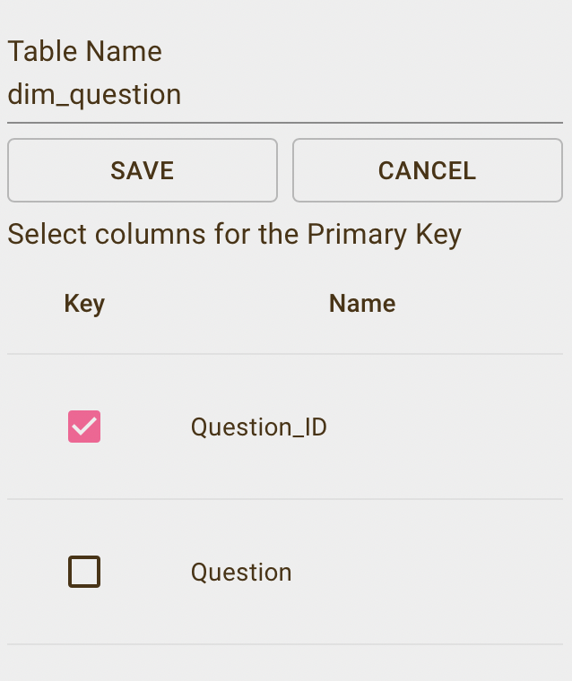

**Step 4:**

I finalized the **Dim_Question** table by including two key columns: **Question_ID** and **Question** The **Question_ID**  serves as the primary key, uniquely identifying each breakout category, while **Question** holds the Question of the survey

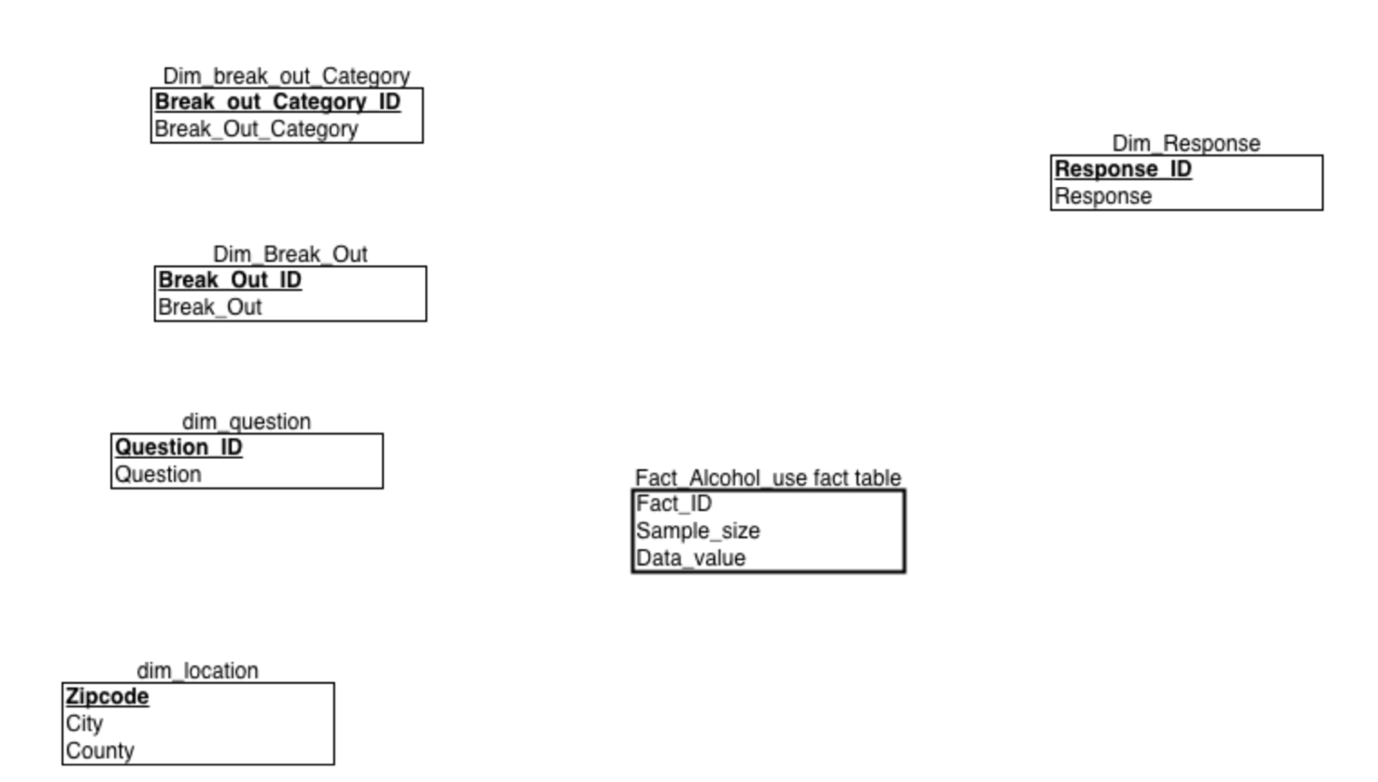

**Creating Dim_location table:**

**Step 1:**

After creating break_out_Category table, I created the **Dim_ location** table to store the zip code, city, and county data.

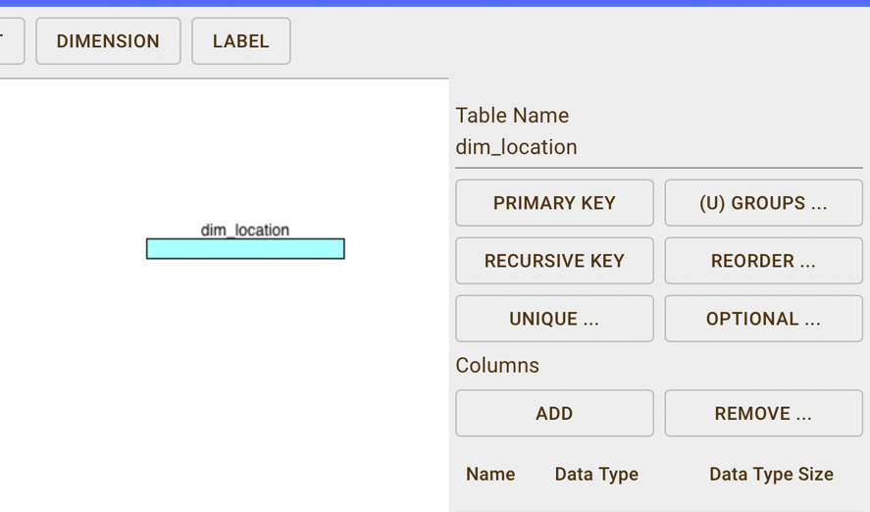

**Step 2:**

I added columns to the **Dim_** locationtable by selecting the "Add" option. I included fields such as **Zipcode** (as an integer) and **City** (as a VARCHAR) and County (as a VARCHAR).

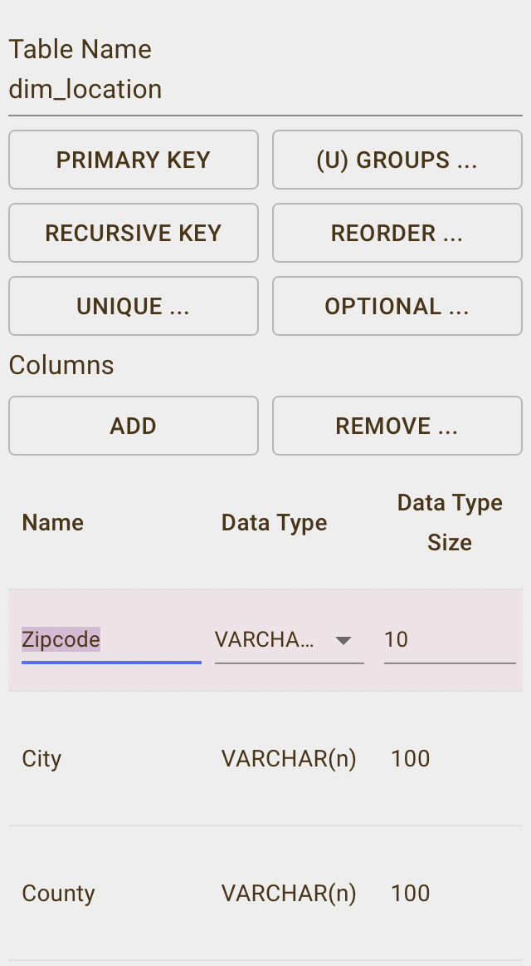

**Step 3:**

I selected the **Primary Key** option for the **Dim_location** table to uniquely identify each record. I chose **zipcode** as the primary key to ensure that each breakout category is distinctly represented in the table.

 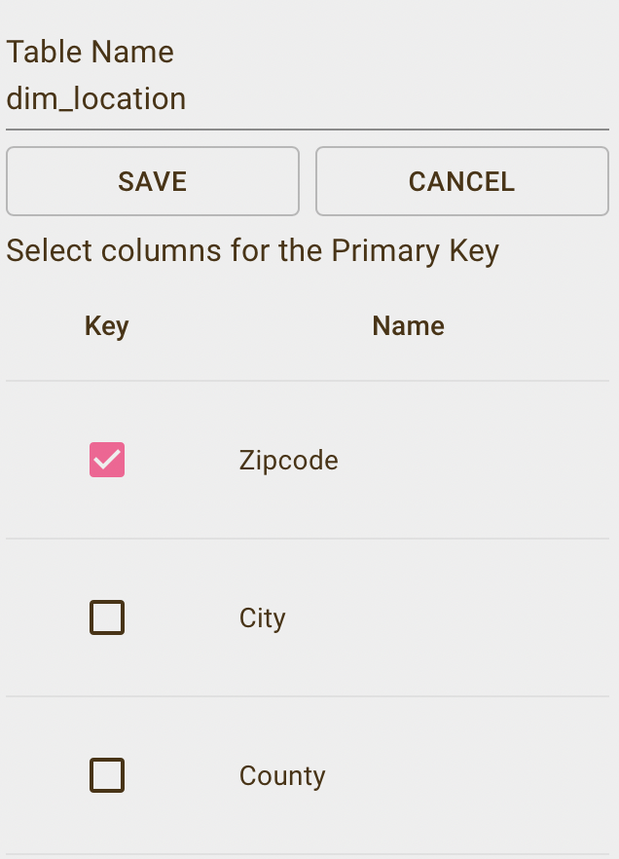

**Step 4:**

I completed the **Dim_location** table by including two key columns: **Zipcode** , City and  **County.** The **Zipcode**  serves as the primary key.

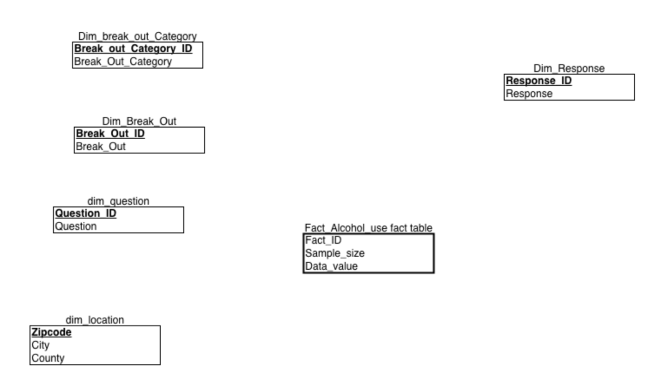

**Creating Dim_response table:**

**Step 1:**

After creating break_out_Category table, I created the **Dim_ response** table to store responses to the question.

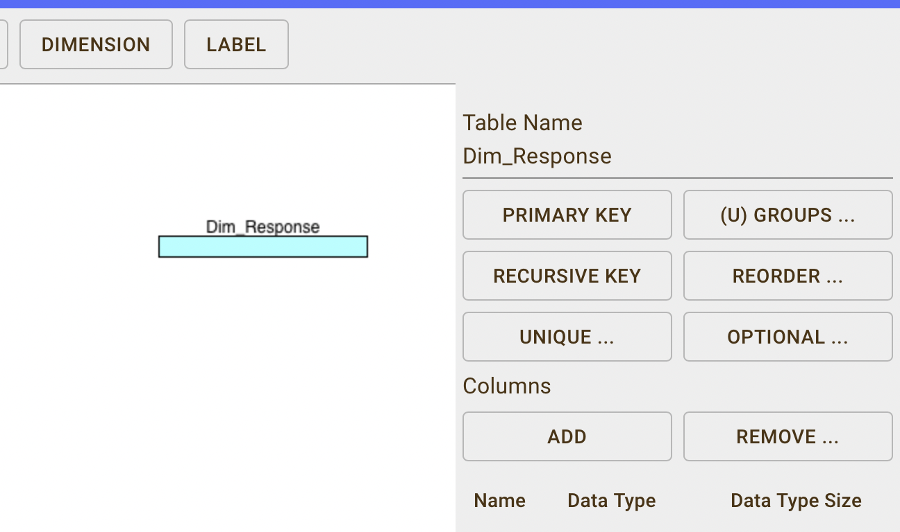

**Step 2:**

I added columns to the **Dim_** responsetable by selecting the "Add" option. I included fields such as **Response_ID** (as an integer) and **Response** (as a VARCHAR) to this table.

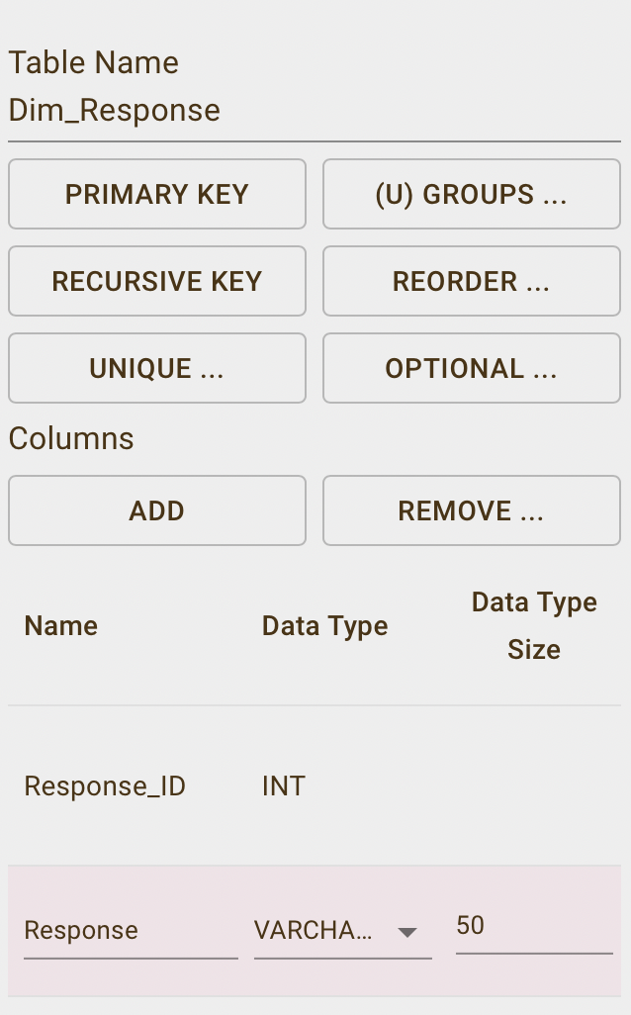

**Step 3:**

I selected the **Primary Key** option for the **Dim_Response** table to uniquely identify each record. I chose **Response_ID** as the primary key to ensure that each breakout category is distinctly represented in the table.

 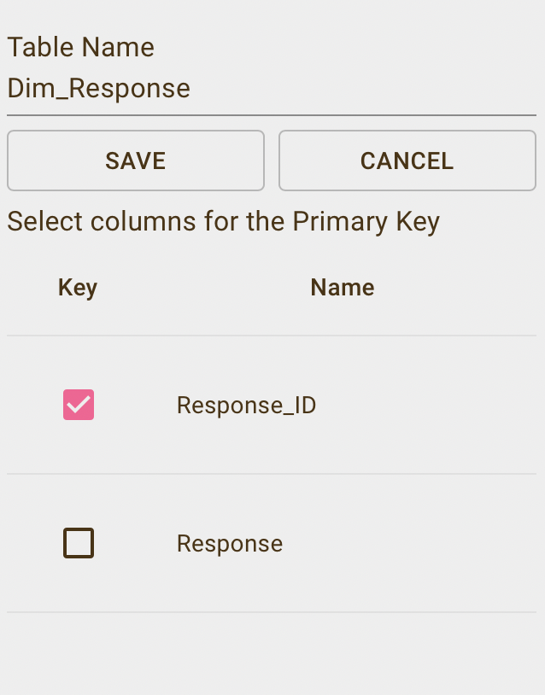

**Step 4:**

I completed the **Dim_Response** table by including two key columns: **Response_ID** as primary key, and Response.

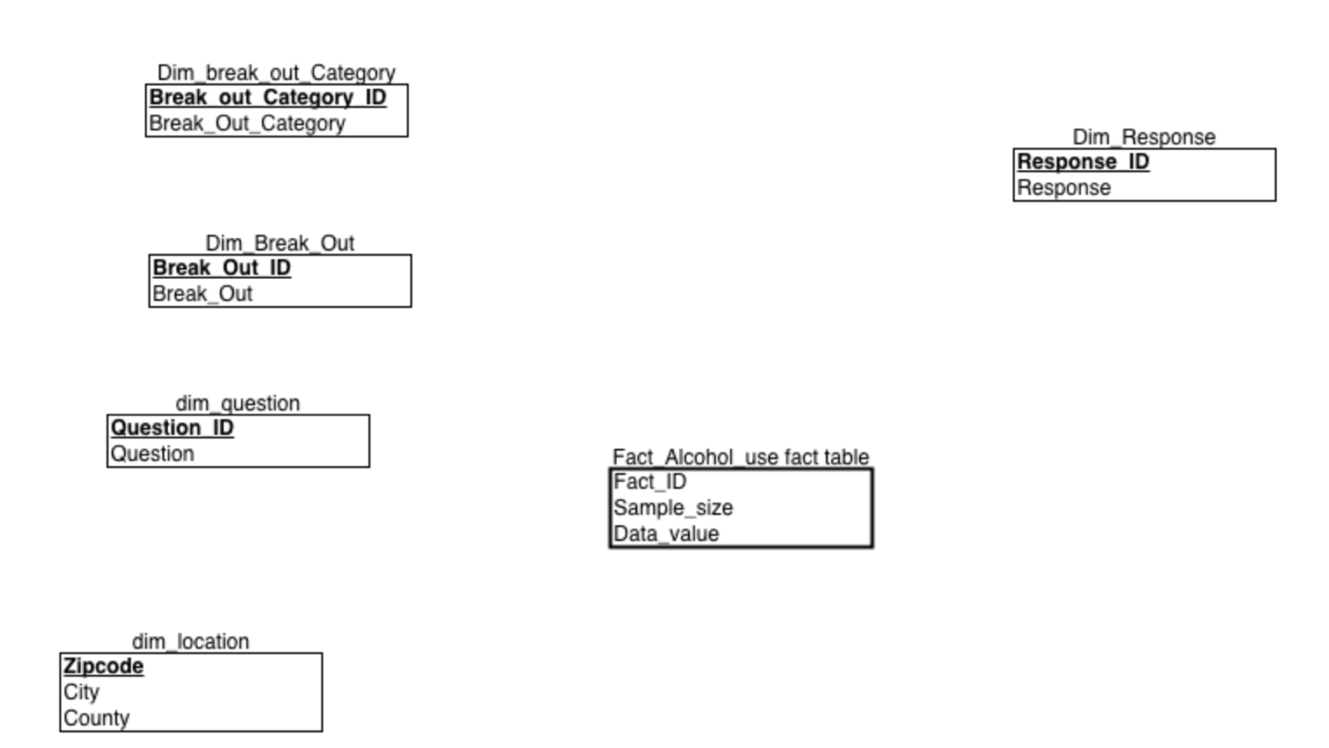

Next, I used the Connect feature to establish relationships between the dimension tables and the fact table, which is essential for building the star schema. In ERDPlus, this process is simple—I clicked on the Connect icon, which enabled me to draw connections between the tables.

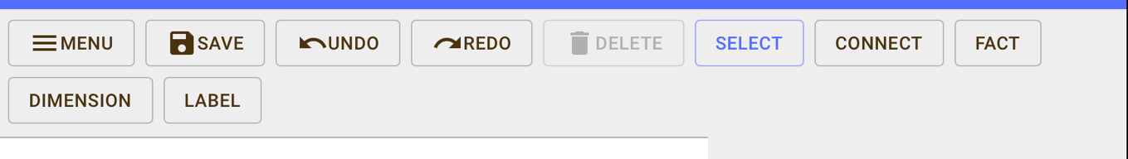

**ERD**

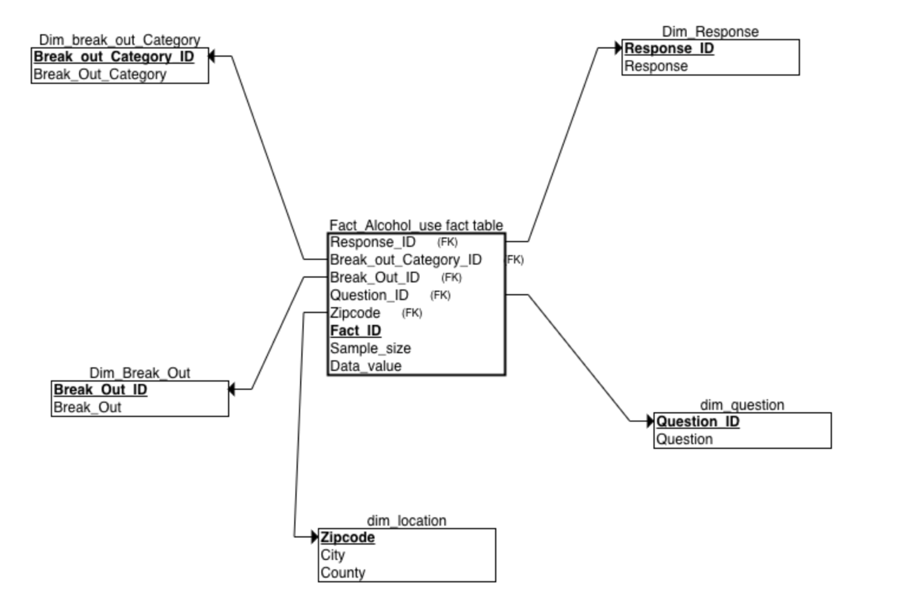

This ERD represents the star schema I created to analyze adolescent alcohol use, with the **Fact_Alcohol_Use** table at the center, surrounded by related dimension tables. The foreign keys were generated automatically when I used the "Connect" function and dragged to link each dimension table to the fact table:

1. **Fact_Alcohol_Use**: This is the main table where the quantitative data, such as **Sample_size**, **Data_value**, and **Fact_ID**, is stored. The fact table is linked to dimension tables through foreign keys, allowing me to analyze the data across different categories.
2. **Dim_Break_Out**: Connected to the fact table by **Break_Out_ID**, this dimension table contains demographic details like age groups or other breakouts. This relationship lets me analyze the alcohol use data based on different demographic groups.
3. **Dim_Break_Out_Category**: Linked via **Break_Out_Category_ID**, this table further classifies the demographic data, providing an additional layer of grouping for the breakouts. It enables more detailed insights by grouping categories like age, income, or education.
4. **Dim_Question**: Connected through **Question_ID**, this table holds the specific survey questions about alcohol consumption (e.g., heavy drinking or binge drinking), allowing me to filter and analyze the fact data based on these specific questions.
5. **Dim_Response**: This table is linked by **Response_ID**, and it holds the responses to the questions stored in the **Dim_Question** table.
6. **Dim_Location**: Connected via **Zipcode**, this table stores geographic information such as **City** and **County**, helping me analyze the data based on location and identify patterns across different regions.

**Implementing the schema in SQL**

The first step in the process was to create the database. I did this by executing the Create command and named it Oklahoma. This initialized the environment where I would store all the necessary tables and data for the project.

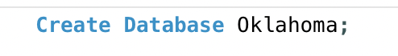

**Step 2:**

After creating the database, I ensured that it was selected for use by executing USE Oklahoma; to make sure that any subsequent commands would apply directly to this specific database. This set the foundation for building the entire schema and conducting further analysis.



**Creating BRFSS_OK Staging Table**

**Step 1:**

I set up a staging table named BRFSS_OK to hold the raw data from the BRFSS survey. The table contains columns like Question, Response, Break_Out, Break_Out_Category, Sample_Size, Data_Value, and ZipCode.

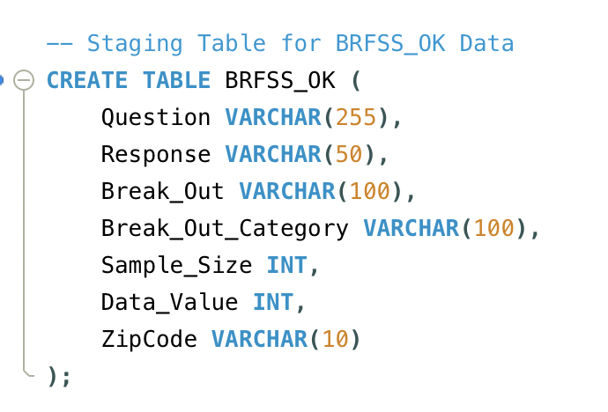

**Step 2:**

I then imported the data into the **BRFSS_OK** table by right-clicking on it and choosing the **Data Import Wizard** option.

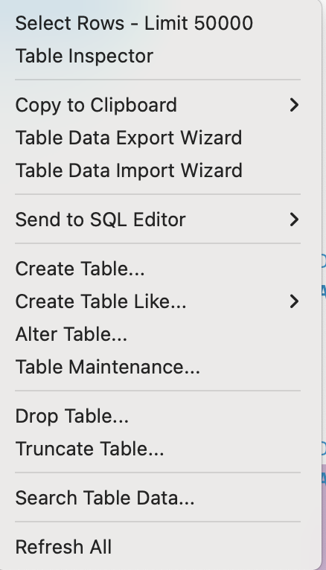

**Step 3:**

Since the data was initially in XLSX format, I converted all the 3 files to CSV using an online [tool](https://cloudconvert.com/).

**Step 4:**

I clicked **Browse** and selected the **BRFSS-OK-3.csv** file that I had downloaded for the assignment.

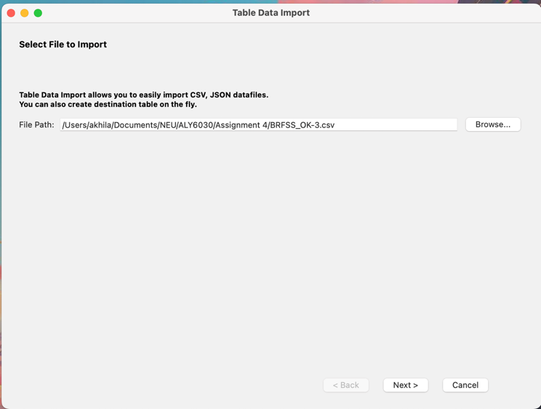

**Step 5:**

After selecting the file for import, I chose the **Use Existing Table** option to ensure the data was imported into the **BRFSS_OK** table I had already created in MySQL.

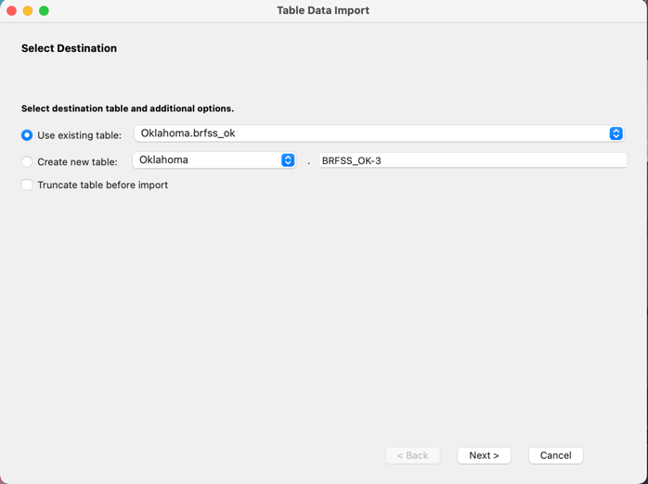

**Step 6:**As part of the import process, I mapped the CSV columns to their respective columns in the **BRFSS_OK** table. I carefully reviewed the mappings to ensure that every CSV field matched the correct column.

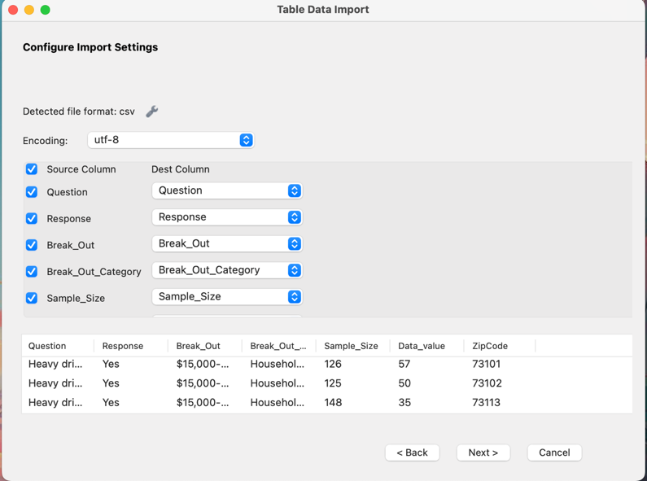

**Step 7:**Once all the mappings were verified, I clicked **Next** to start the import process.

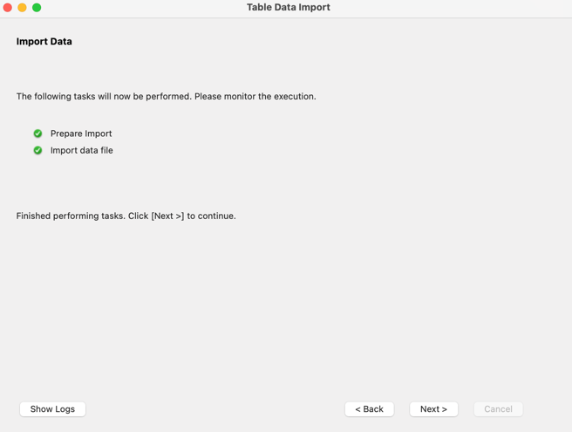

**Step 8:**

MySQL Workbench processed the CSV file and inserted the data into the **BRFSS_OK** table. After the process was complete, I checked the table to ensure the data was imported correctly.

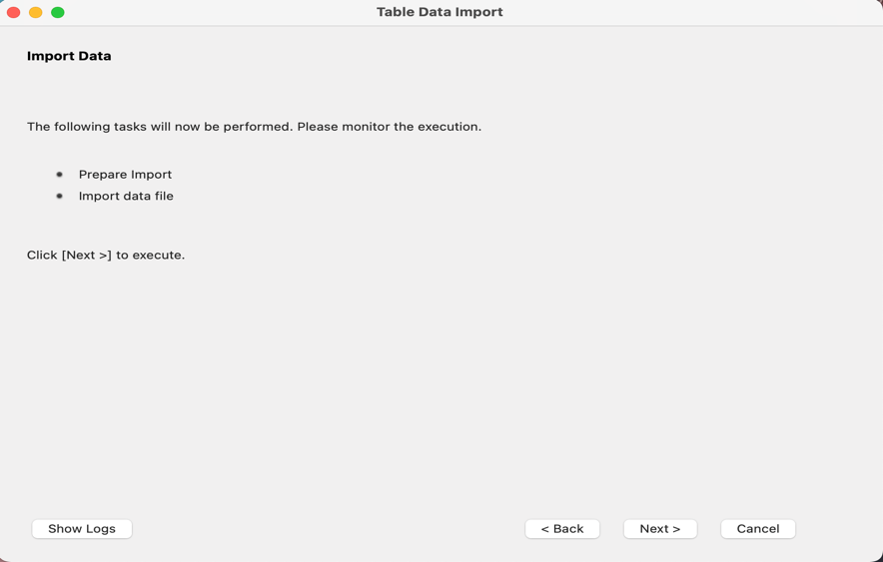

**Step 9:**

After the import, I verified that 667 records were successfully loaded into the table.

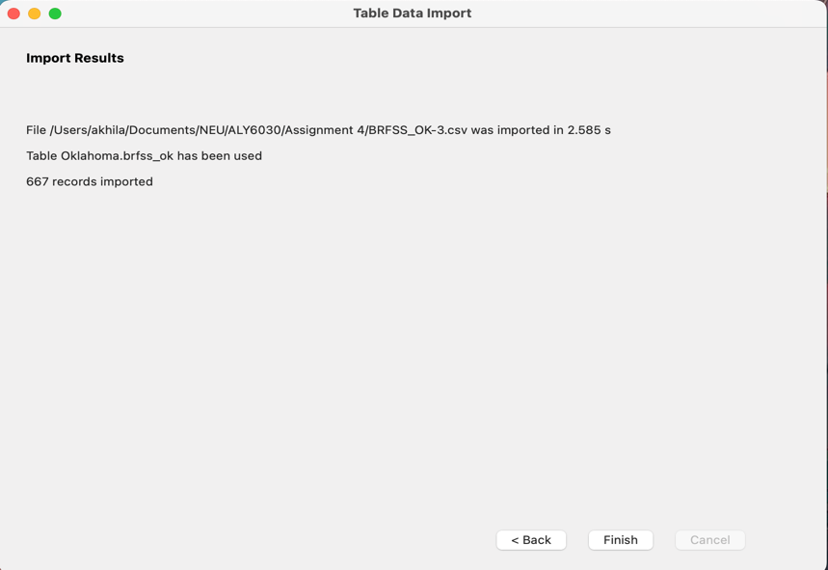

**Creating Demographics_OK Staging Table**

**Step 1:**

I set up a staging table named Demographics_OK to hold the raw data from the BRFSS survey. The table contains columns like Zipcode, City and County.

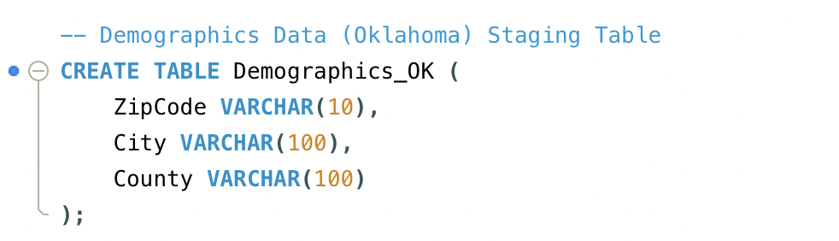

**Step 2:**

I then imported the data into the Demographics **_OK** table by right-clicking on it and choosing the **Data Import Wizard** option.



**Step 3:**

I clicked **Browse** and selected the **Demographics-OK-1.csv** file.

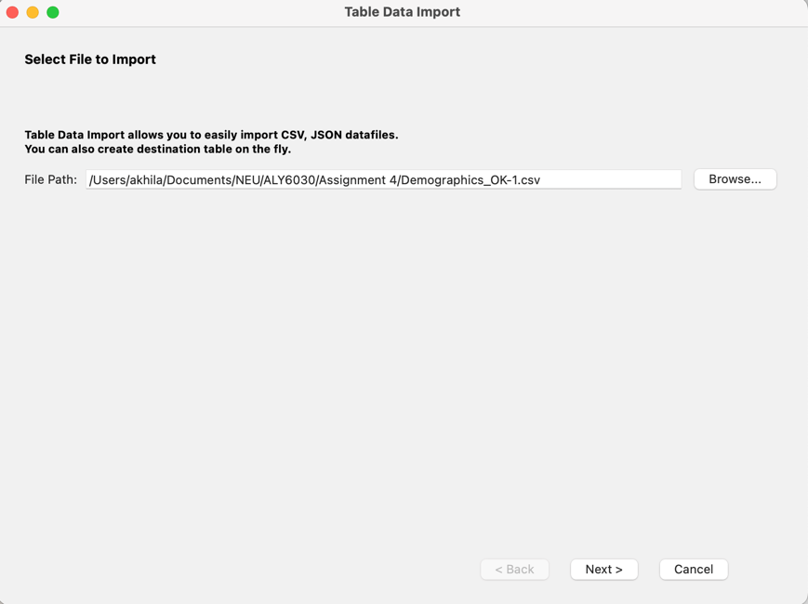

**Step 4:**

After selecting the file for import, I chose the **Use Existing Table** option to ensure the data was imported into the **Demographics_OK** table I had already created in MySQL.

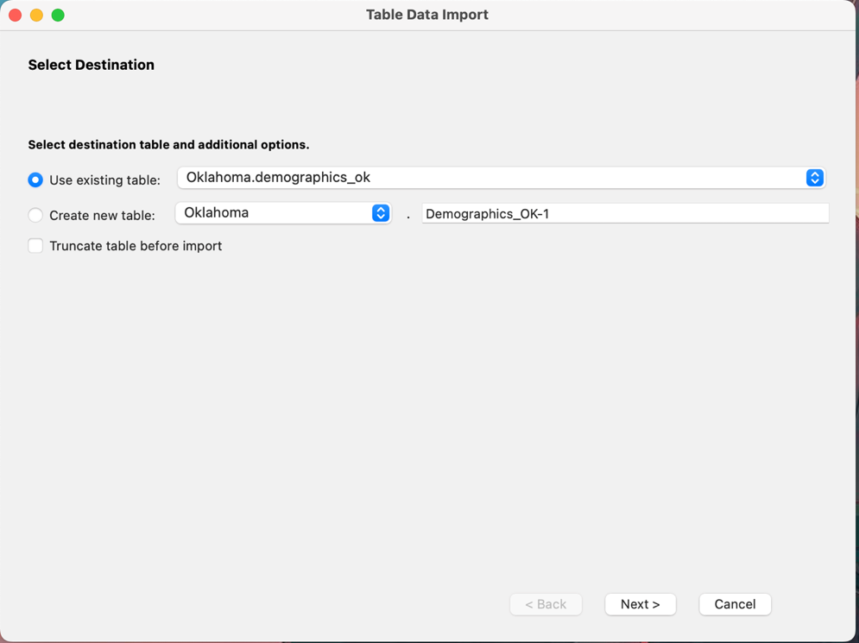

**Step 5:**As part of the import process, I mapped the CSV columns to their respective columns in the **Demographics_OK** table. I carefully reviewed the mappings to ensure that every CSV field matched the correct column.

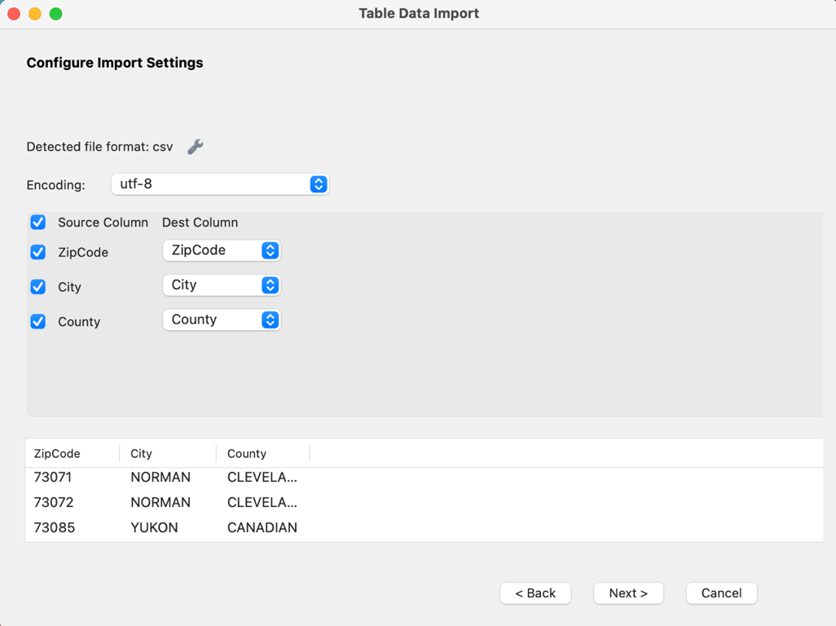

**Step 6:**Once all the mappings were verified, I clicked **Next** to start the import process.

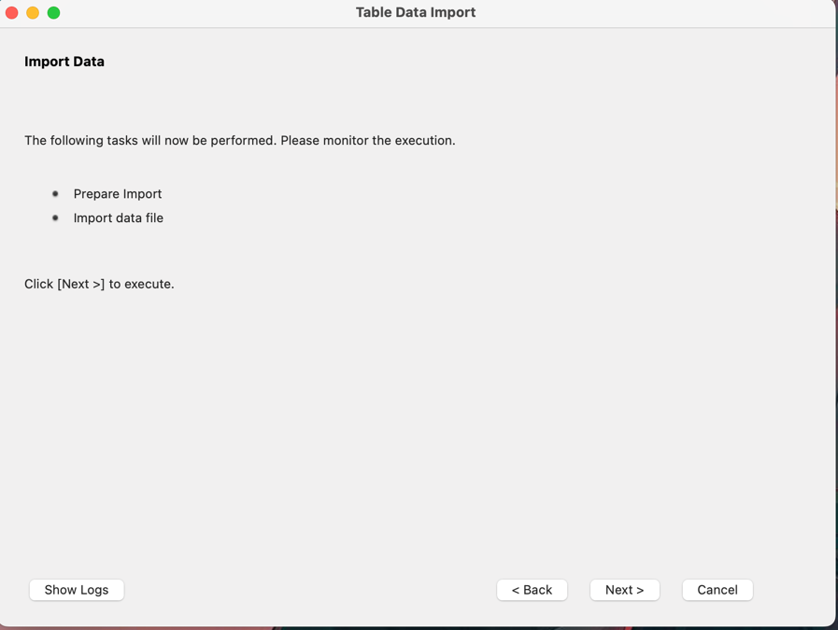

**Step 7:**

MySQL Workbench processed the CSV file and inserted the data into the **BRFSS_OK** table. After the process was complete, I checked the table to ensure the data was imported correctly.

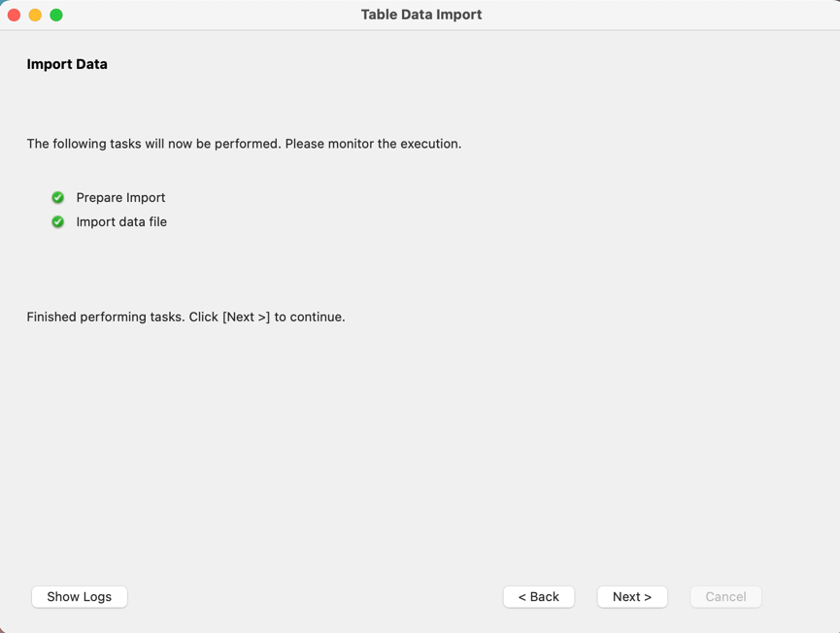

**Step 8:**After the import, I verified that 764 records were successfully loaded into the table.

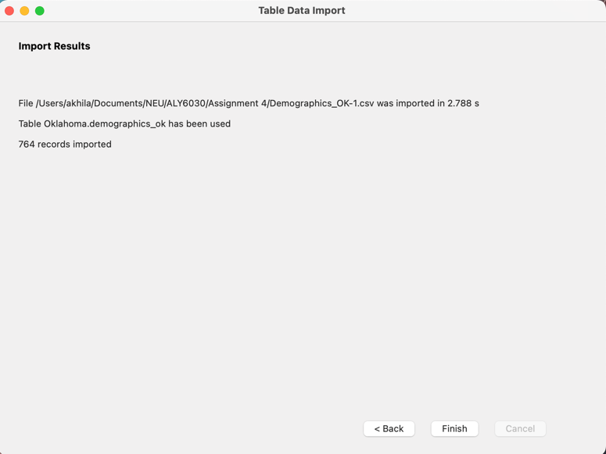

**Creating Demographics_1 Staging Table**

**Step 1:**

I set up a staging table named Demographics_1 to hold the raw data from the BRFSS survey. The table contains columns like Zipcode, City and County.

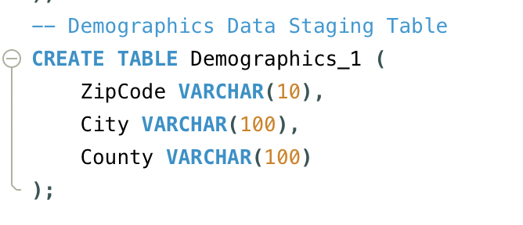

**Step 2:**

I then imported the data into the Demographics **_1** table by right-clicking on it and choosing the **Data Import Wizard** option.



**Step 3:**

I clicked **Browse** and selected the **Demographics-1.csv** file.

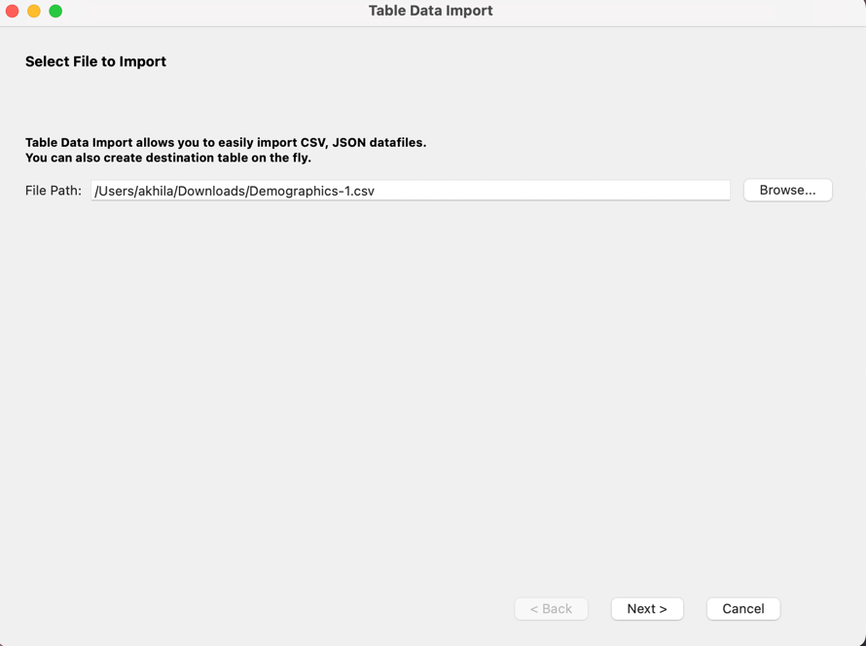

**Step 4:**

After selecting the file for import, I chose the **Use Existing Table** option to ensure the data was imported into the **Demographics_1** table I had already created in MySQL.

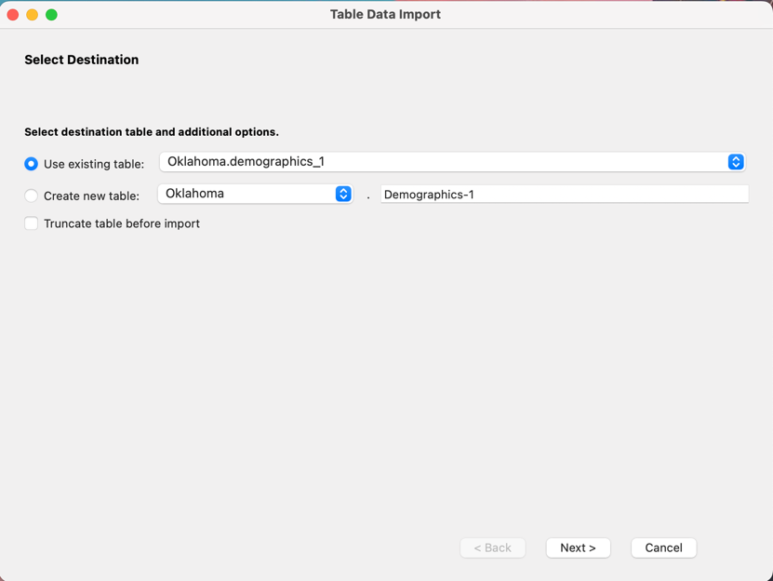

**Step 5:**As part of the import process, I mapped the CSV columns to their respective columns in the **Demographics_1** table. I carefully reviewed the mappings to ensure that every CSV field matched the correct column.

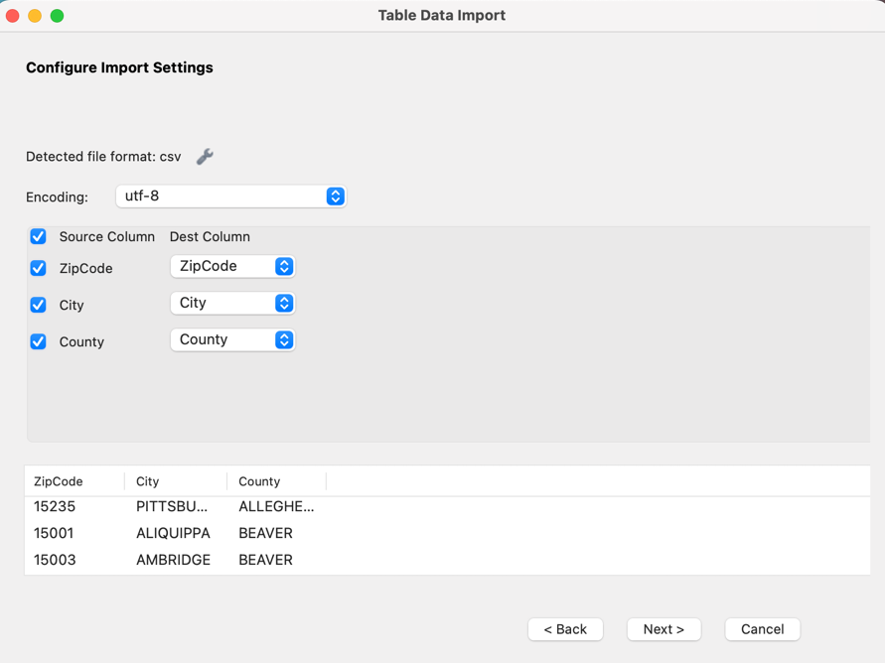

**Step 6:**Once all the mappings were verified, I clicked **Next** to start the import process.

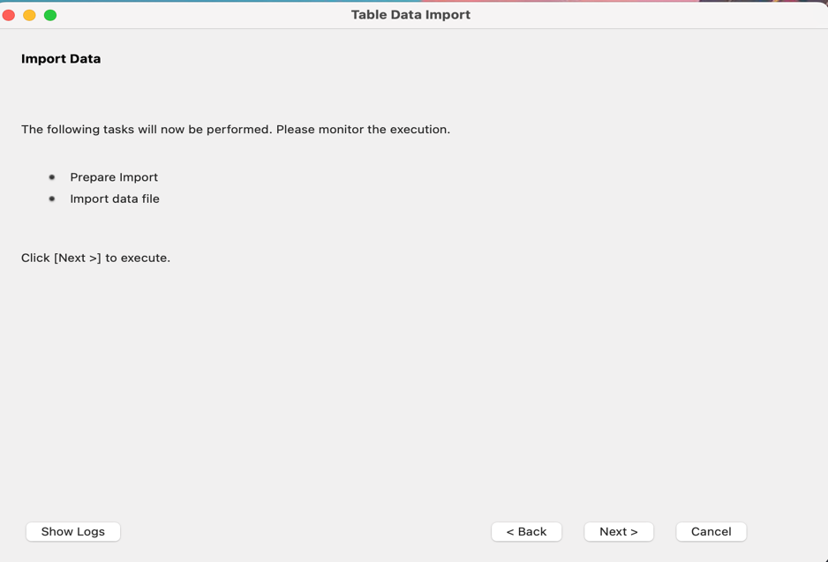

**Step 7:**

MySQL Workbench processed the CSV file and inserted the data into the **BRFSS_OK** table. After the process was complete, I checked the table to ensure the data was imported correctly.



**Step 8:**After the import, I verified that 2185 records were successfully loaded into the table.

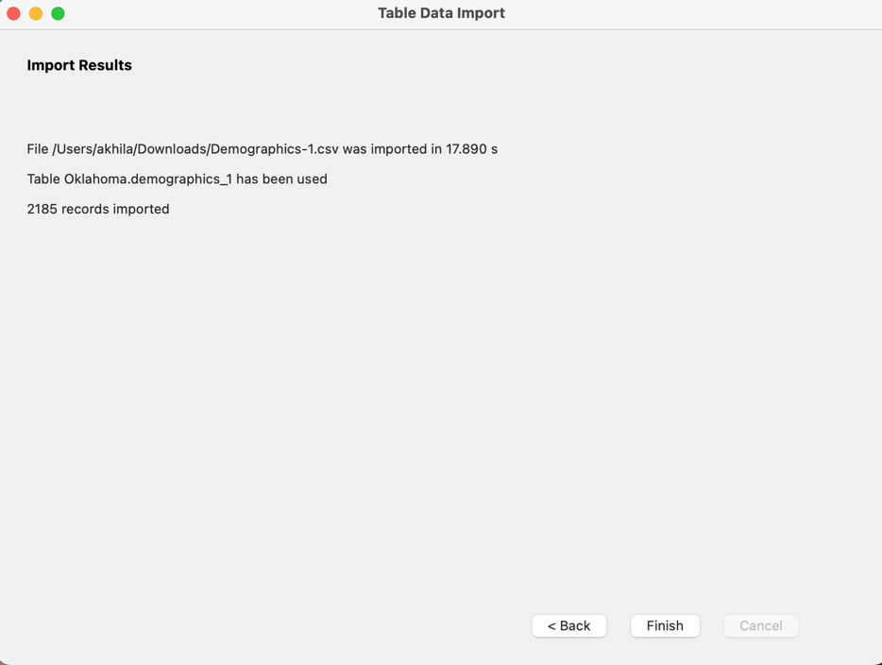

**CREATING DIMENSION TABLES**

**Creating Dimension table for questions:**

I created the **Dim_Question** table to store unique questions from the dataset, using **Question_ID** as the primary key with auto-increment for each record.

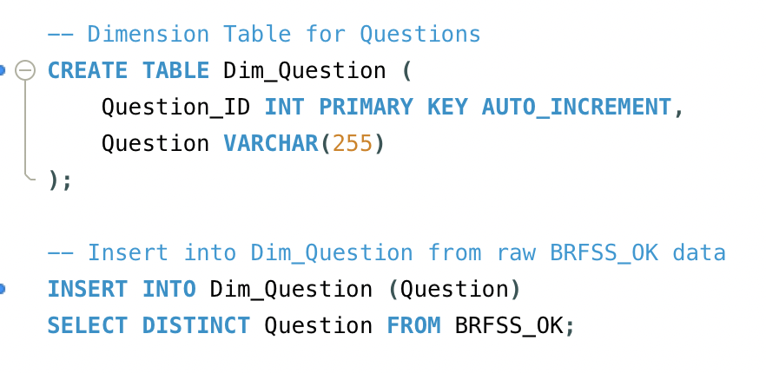

Inserting Data into dim_question:

Then, I inserted distinct questions from the **BRFSS_OK** table into **Dim_Question** to populate it with the relevant data.



**Creating Dimension table for Responses:**

I created the **Dim_Response** table to store the distinct responses from the dataset, with **Response_ID** set as the primary key and auto-incrementing for each record.

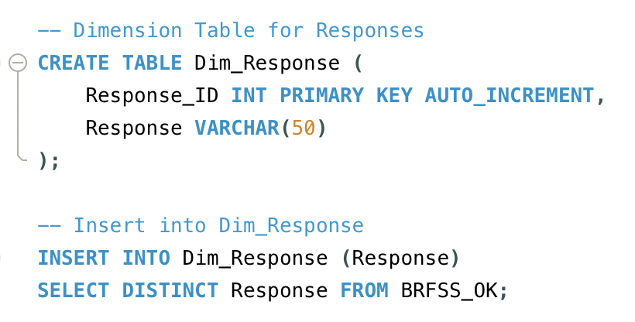

**Inserting Data into dim_response:**

I then inserted unique responses from the **BRFSS_OK** table into the **Dim_Response** table to ensure all the response data is captured correctly.



**Creating Dimension table for Locations:**

I created the **Dim_Location** table to store location data, using **ZipCode** as the primary key along with the corresponding **City**and **County** columns.

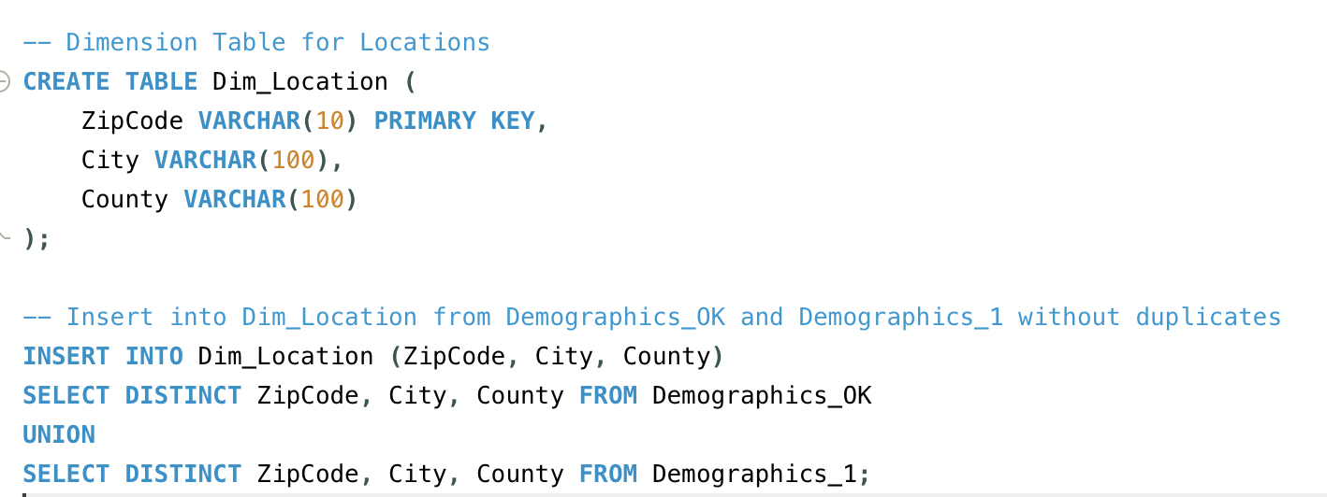

**Inserting Data into dim_location:**

Then, I inserted distinct location records by selecting and combining data from both Demographics_OK and Demographics_1, ensuring no duplicates were imported.

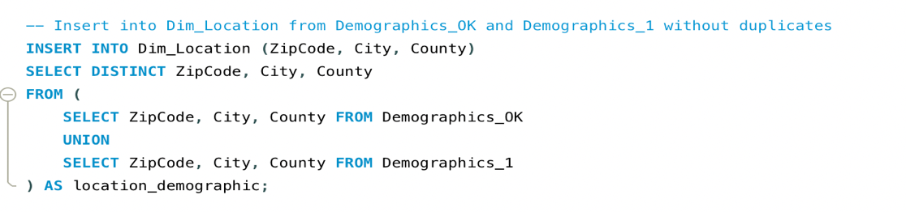

**Creating Dimension table for Break_Out:**I created the **Dim_Break_Out** table to store information about different demographic groups or categories, with **Break_Out_ID** as the primary key. 

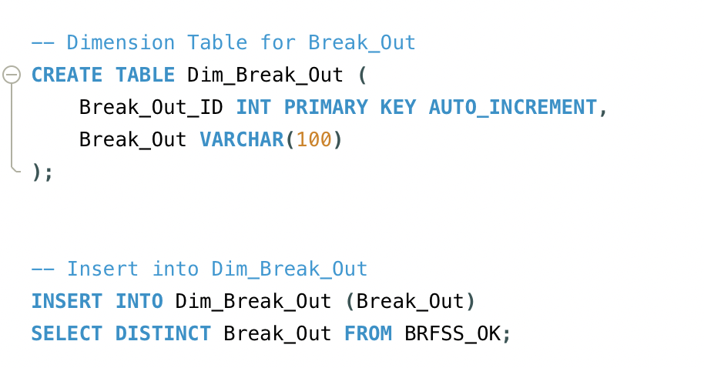

**Inserting Data into Dim_Break_Out:**After creating the Break_Out table, I inserted distinct **Break_Out** values from the **BRFSS_OK** table into this dimension table to ensure all unique demographic categories are represented.



**Creating Dimension table for Break_Out_ Category:**

I created the **Dim_Break_Out_Category** table to capture the categories associated with each breakout group, using **Break_Out_Category_Id** as the primary key.

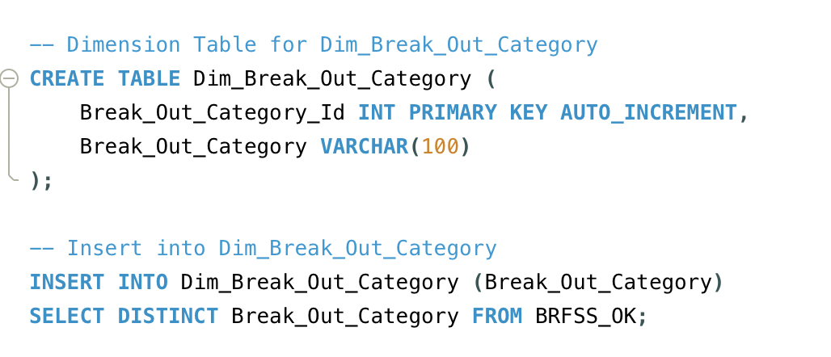

**Inserting Data into Dim_Break_Out_Category:**

Afterward, I populated this table by inserting distinct **Break_Out_Category** values from the **BRFSS_OK** table, ensuring each category is represented without duplicates.



**Creating Fact Table:**At last I created the **Fact_Alcohol_Use** table to store the key quantitative data related to alcohol use, with **Fact_ID** as the primary key. This table also includes several foreign keys linking it to the dimension tables such as **Dim_Location**, **Dim_Question**, **Dim_Response**, **Dim_Break_Out**, and **Dim_Break_Out_Category**, which will help in performing multi-dimensional analysis.

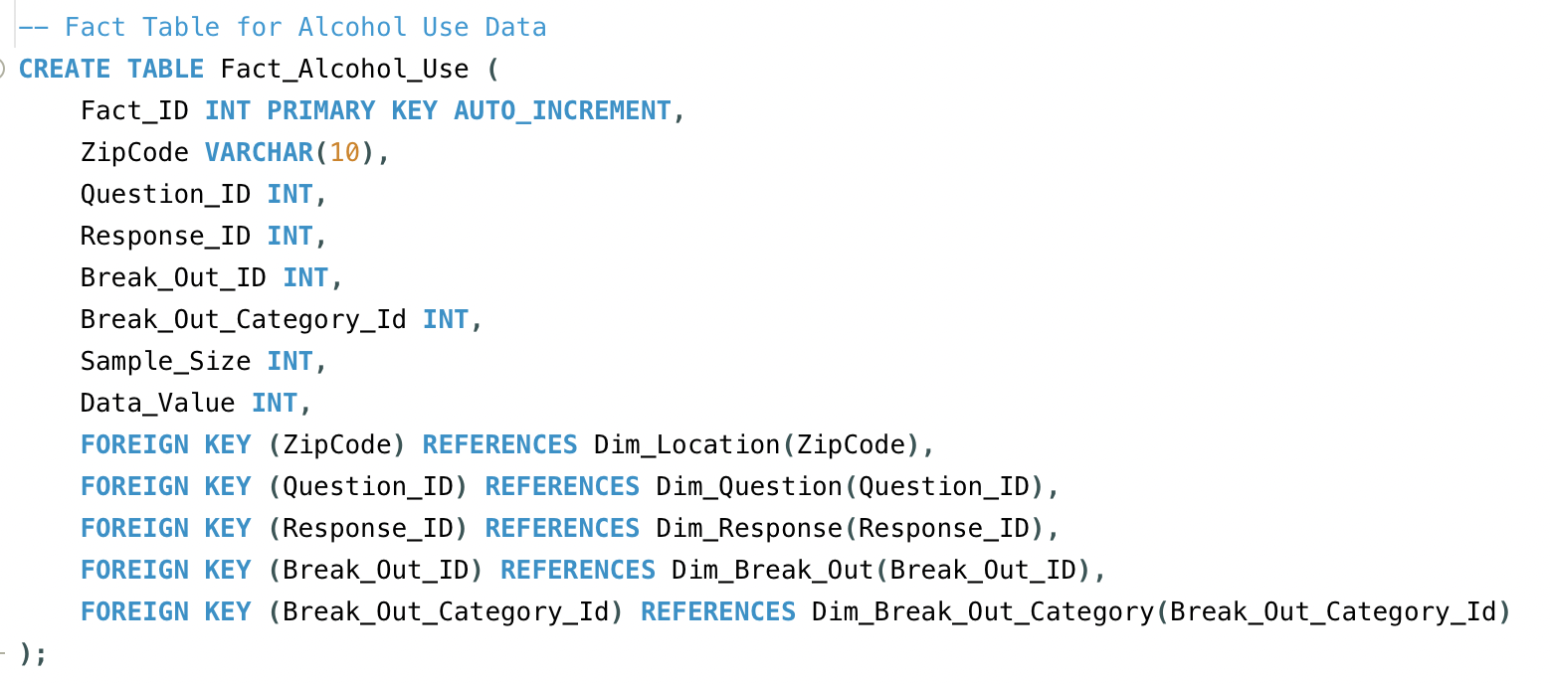

I inserted data into the **Fact_Alcohol_Use** table by joining it with the dimension tables to map the corresponding IDs, such as **Question_ID**, **Response_ID**, **Break_Out_ID**, and **Break_Out_Category_Id**. This step allowed me to link the detailed data from the **BRFSS_OK** table with the appropriate dimension tables for a more structured analysis.

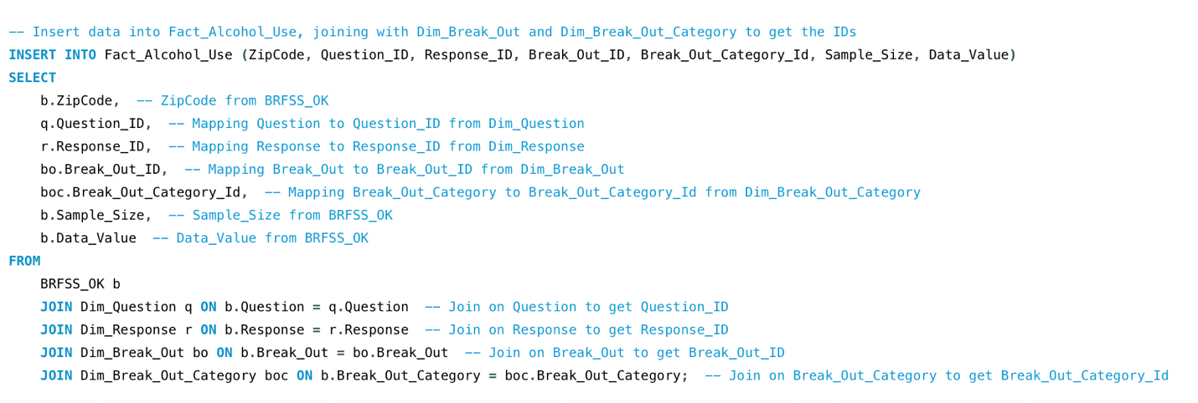

I dropped the temporary tables BRFSS_OK, Demographics_OK, and Demographics_1 after successfully transferring the relevant data into the appropriate fact and dimension tables. This step was essential for cleaning up the database and removing any staging tables that were no longer needed to decrease redundancy.

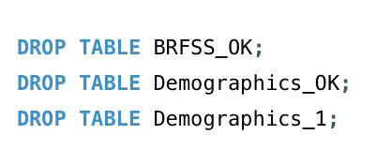

**AREAS OF OK HAVING HIGHEST AND LOWEST PERCENT OF RESPONDENTS FOR ADOLESCENT ALCOHOL ABUSE:**

**BY CITY:**

The query sums the **Sample_Size** (total number of participants) and **Data_Value** (number of respondents who reported alcohol abuse) for the 18-24 age group. Using these values, it calculates the percentage of respondents who identified as heavy drinkers by dividing the sum of **Data_Value** by the sum of **Sample_Size** and multiplying by 100. This calculation is handled within a **CASE** statement to ensure a valid output even if the sample size is zero.

The **JOIN** clauses link the fact table with the dimension tables, such as **Dim_Location** for city information and **Dim_Break_Out** for the age group filter. Since only Oklahoma City has data for the 18-24 age group, the output is limited to this city. The **GROUP BY** clause ensures the results are aggregated by city.

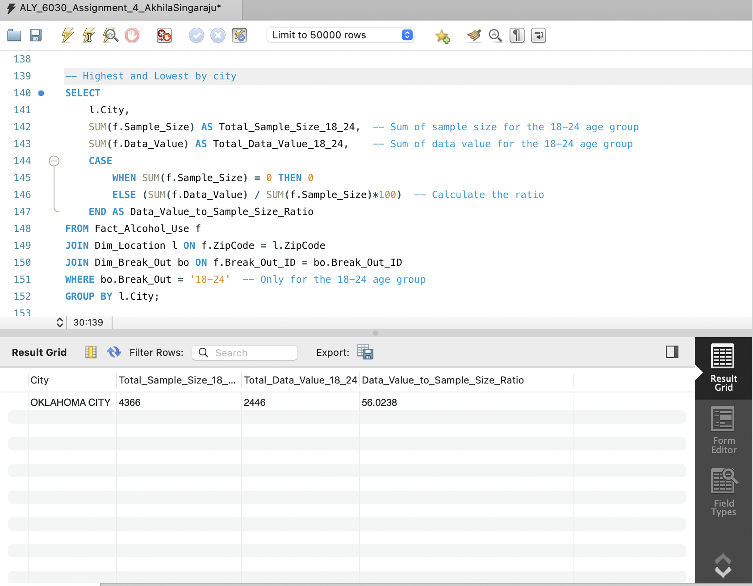

The output shows that Oklahoma City has a total sample size of **4366**, with **2446** respondents reporting alcohol abuse, resulting in a percentage of **56.02%**. This single output highlights that over half of the surveyed adolescents in the 18-24 age group in Oklahoma City reported alcohol abuse, giving us insight into the prevalence of alcohol use among this population.



The 18-24 Age group data is available only for the Oklahoma City.

BY COUNTY:

In this query, I focused on calculating the percentage of respondents within the 18-24 age group who reported alcohol abuse, this time grouped by county. The objective was to determine which counties in Oklahoma had the highest and lowest percentages of adolescent alcohol abuse.

The query begins by selecting the **County** and using **SUM()** functions to calculate both the total sample size and the total number of respondents who reported alcohol abuse. The **CASE** statement calculates the ratio of heavy drinkers to the total sample size as a percentage. If the sample size is zero, the query returns zero; otherwise, it divides the total number of respondents (alcohol users) by the total sample size and multiplies by 100 to give the percentage. The **JOIN** clauses link the fact table to the **Dim_Location** table (for county data) and the **Dim_Break_Out** table to filter for the 18-24 age group. The **GROUP BY** clause aggregates the results by county.

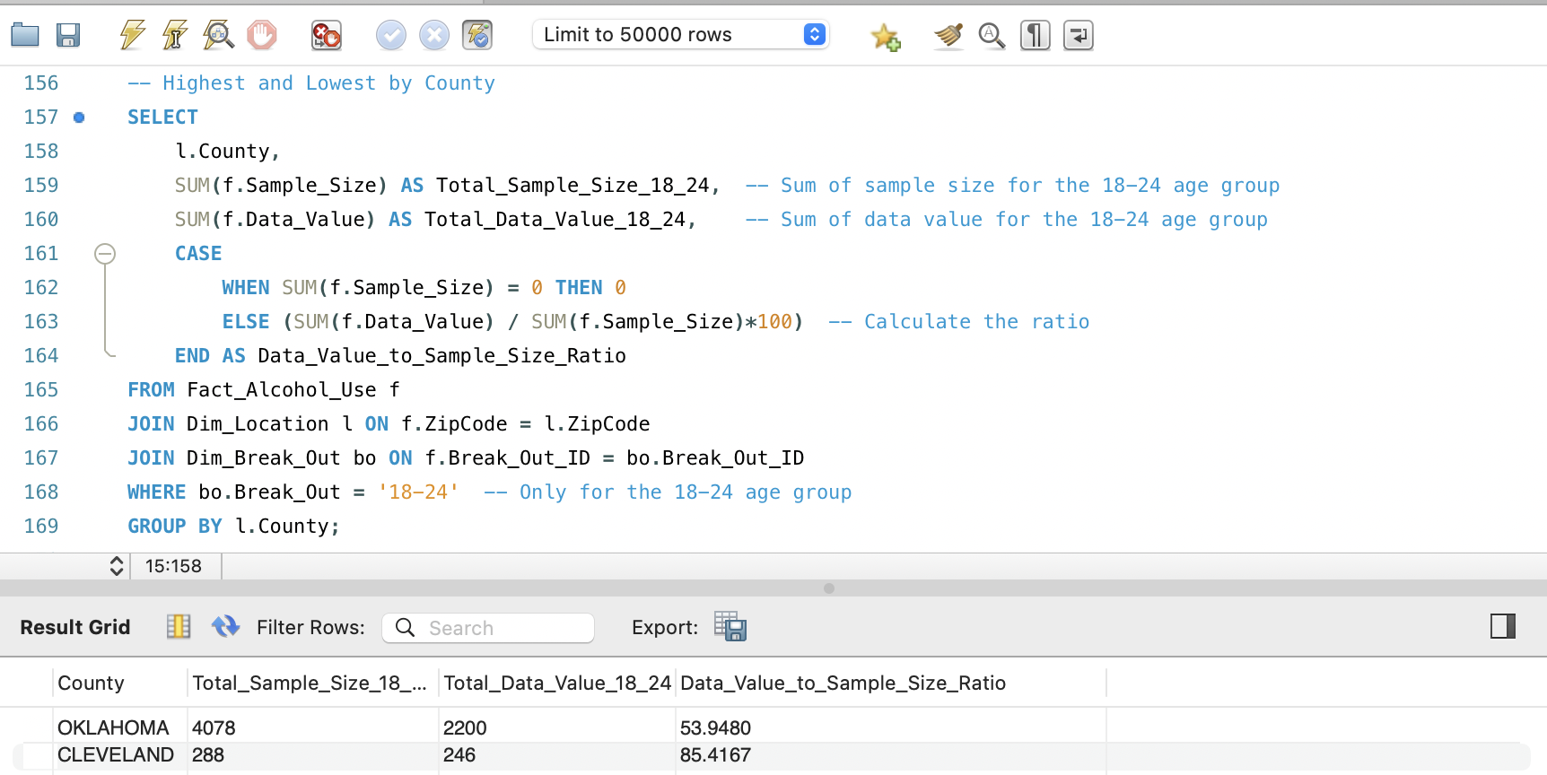

The output shows two counties: Oklahoma and Cleveland. In **Oklahoma County**, the total sample size is **4078**, with **2200** respondents reporting alcohol abuse, resulting in a ratio of **53.95%**. In **Cleveland County**, the sample size is **288**, with **246** respondents reporting alcohol abuse, giving a much higher percentage of **85.42%**.

This analysis indicates that Cleveland County shows a higher proportion of alcohol abuse among respondents in the 18-24 age group.  
  
Highest percent of respondents for adolescent : Cleveland – 85.41%

Lowest percent of respondents for adolescent : Cleveland – 53.94%



**CONCLUSION**

In this assignment, the primary goal was to analyze adolescent alcohol use in Oklahoma and identify the areas with the highest and lowest percentages of alcohol abuse among respondents aged 18-24. I am pleased to conclude that the goals and expectations were met successfully. By using SQL queries to analyze the dataset from the BRFSS, I was able to extract meaningful insights, calculate alcohol abuse percentages by city and county, and highlight significant patterns in the data. The structured analysis provided clear results, specifically identifying Oklahoma and Cleveland counties as key areas for further investigation due to their high alcohol abuse rates among adolescents.

**Pros:**

* **MySQL and SQL Queries**: Using MySQL allowed for efficient data manipulation and analysis, particularly with its ability to handle large datasets. The use of SQL for querying the dataset was straightforward and effective in extracting the necessary data and performing calculations. The ability to join tables and aggregate data was essential for deriving insights from the dataset.
* **Star Schema Design**: Structuring the data in a star schema helped streamline the querying process. By organizing the data into fact and dimension tables, I could easily connect related data points and execute queries with minimal redundancy.

**Cons:**

* **Data Limitations**: The dataset was limited to just Oklahoma City for the 18-24 age group. While this provided useful insights for these areas, it would have been more impactful to have data for other cities and counties for comparison.
* **Manual Data Mapping**: Although SQL handled the analysis well, manually creating the star schema and ensuring correct data mapping took some time.

### What I Would Do Differently

If I were to approach this assignment again, I would consider integrating a visualization tool like **Tableau** or **Power BI** to complement the SQL analysis. This would enhance the presentation of results and make it easier to interpret the findings visually. Additionally, I would explore more sophisticated SQL functions or stored procedures to automate parts of the data transformation and analysis process. Lastly, I would aim to use a more comprehensive dataset that includes multiple cities and counties, allowing for a more in-depth comparison of adolescent alcohol use across different regions of Oklahoma. This would provide a broader perspective and make the analysis even more impactful.

**REFERENCES**

1. *W3Schools.com*. (n.d.-l). <https://www.w3schools.com/sql/sql_like.asp>
2. *W3Schools.com*. (n.d.-m). <https://www.w3schools.com/sql/sql_case.asp>
3. *W3Schools.com*. (n.d.-n). <https://www.w3schools.com/sql/sql_avg.asp>